INDIAN SCHOOL ALWADI ALKABIR
DEPARTMENT OF SOCIAL SCIENCE
PRE-MID TERM ASSESSMENT: 2023-24

CLASS: VII Max: Marks: 30
Date: 28/05/2023 Time: 1Hour.
General Instructions: -
1. Ensure that you have written your name and roll number correctly.
2. This Question paper has two parts, Section A (History)B (Geography).
3. All questions are compulsory.
4. All the answers must be correctly numbered as in the question paper in the Answer sheet
provided

 | SECTION - A (HISTORY) 10 Marks
I | Choose the correct option: - | 1 Marks
1 | The professionals who copied down the manuscripts are called  (a) Warrior (b) Historian (c) Al-Idrisi (d) Scribes | 1 Mark
II | Fill in the blanks: - | 2 Marks
2 | Ziyauddin Barani was a ____________century chronicler. | 1 Mark
3 | Amir Khusrau was a ____________. | 1 Mark
III | Answer in one or two sentences: - | 2 Marks
4 | Who is a ‘cartographer’? | 1 Mark
5 | Who had accepted the authority of the early Muslim leaders? | 1Mark
IV | Answer the following questions: - | 2 Marks
6 | Observe the given picture and answer the following questions: -.  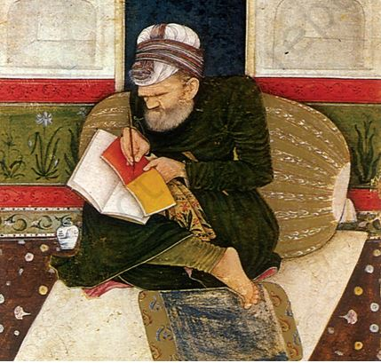  a) Why is this painting called miniature?  b) What is the scribe doing in the painting? | 2 Marks
V | Answer in detail: - | 3 Marks
7 | How were the affairs of jatis regulated? | 3 Marks
 | SECTION - B (CIVICS) 10 Marks
VI | Choose the correct option: - | 1 Mark
8 | The first state to introduce Midday meal scheme.  (a)Kerala (b)Assam (c) Karnataka (d) Tamil Nadu | 1 Mark
VII | Fill in the blanks: - | 1 Mark
9 | _____________means equal right to vote. | 1 Mark
VIII | Match the Following : - | 2 Marks
10 | Prohibition of Discrimination (a) Dr B.R.Ambedkar | 1 Mark
11 | Indian Constitution (b) Article 15 | 1 Mark
 | (c) Article 13
IX | Answer in one or two sentences: - | 1 Mark
12 | What is Civil Rights Movement? | 1 Mark
X | Case Study Question: - | 2 Marks
13 | Carefully read the passage and answer the questions that follow:  When persons are treated unequally, their dignity is violated. The dignity of both Omprakash Valmiki and the Ansaris was violated because of the way in which they were treated. By picking on him and making him sweep the school, because of his caste, Omprakash Valmiki’s schoolmates and teachers hurt his dignity badly and made him feel as if he was less than equal to all other students in the school. Being a child, Omprakash Valmiki could do very little about the situation that he was in. It was his father who, on seeing his son sweep, felt angry by this unequal treatment and confronted the teachers. The Ansaris’ dignity was also hurt when persons refused to lease their apartments to them. However, when the property dealer suggested that they change their name, it was their dignity or self-respect that made them refuse this suggestion.  a. What did the teachers ask Omprakash Valmiki to do?  b. How was Ansari’s dignity humiliated? | 2 Marks
XI | Answer in detail: - | 3 Marks
14 | Why is Universal Adult Franchise important in Democracy? | 3 Marks
 | SECTION - C (GEOGRAPHY) 10 Marks
XII | Choose the Correct Option: - | 2 Marks
1 | The solid crust or the hard-top layer of the earth.  a) Hydrosphere b) Lithosphere c) Atmosphere d) Biosphere | 1 Mark
2 | The world of non-living elements are called __________  (a) Ecosystem (b) Biotic (c) Abiotic (d) Biosphere | 1 Mark
XIII | Fill in the blanks: - | 1 Mark
3 | _____________ interact with the environment and modify it according to their needs. | 1 Mark
XIV | Match the following: - | 1 Marks
4 | Human environment a) Road | 1 Mark
 | b) Community
XV | Answer in one or two sentences: - | 1 Mark
5 | Give two examples of natural environment. | 1 Mark
XVI | Answer the following questions: - | 2 Marks
6 | Draw and label the diagram of the domains of Environment. | 2 Marks
XVII | Answer in detail: - | 3 Marks
7 | What is lithosphere? | 3 Marks

